Dual Boot Setup Guide: Windows 11 & Ubuntu

# ReadMe:

|  |  |
| --- | --- |
| Document | Dual Boot Setup Guide: Windows 11 & Ubuntu |
| Verison | v0 |
| Last Modified | 16th Apr 2025 |
| Author | Anusha Devi |

Contents

ReadMe: 1

1. Introduction 1

2. Prerequisites 1

3. Required Softwares 1

4. Get the bitlocker Key 1

5. Disable Secure Boot 2

6. Prepare the Ubuntu Bootable USB 3

7. Creating a partition to dual-boot Linux 4

8. Installing Linux to dual-boot with Windows 11 5

# Introduction

This guide outlines the steps to successfully set up a dual-boot system with Windows 11 and Ubuntu Linux, allowing users to choose either operating system at startup.

# Prerequisites

Before starting the installation process, ensure the following:

* Windows 11 is already installed on your machine.
* Minimum 200 GB of free storage space.
* A USB flash drive (8 GB or more).
* Move all your data from the C drive to the D drive to prevent the data loss

# Required Softwares

* Ubuntu ISO file
  + Download the latest Ubuntu ISO (Ubuntu 24.04)
  + Link to Download: <https://ubuntu.com/download/desktop>
* A bootable USB creator tool – Rufus is used to create Bootable USB Drives
  + Link to Download: https://rufus.ie/en/

# Get the BitLocker key

* Contact the IT team and get the BitLocker key.
* Raise a ticket on Creative Hub.

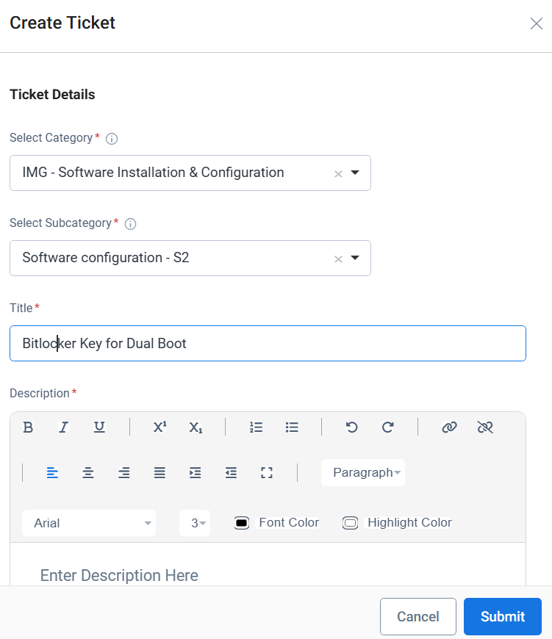

# Disable Secure Boot

* Open the Start menu and go to the power menu in the bottom right corner. Then, hold **Shift** on your keyboard and click on **Restart**. You'll be taken to a blue screen that looks somewhat like below

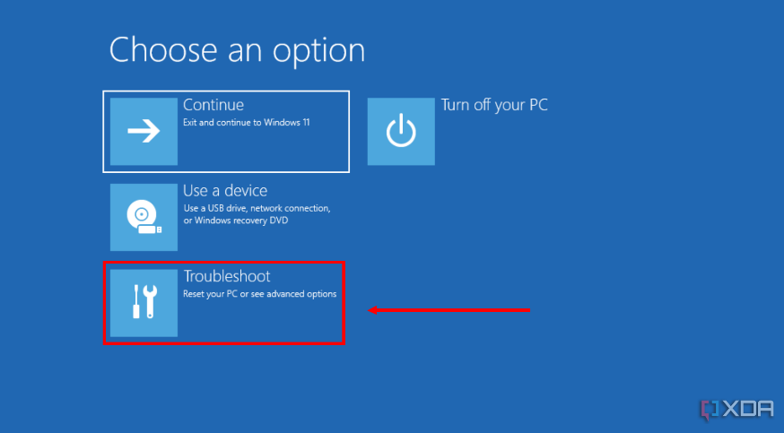

* Here, choose Troubleshoot, followed by Advanced options.
* Select UEFI Firmware Settings.

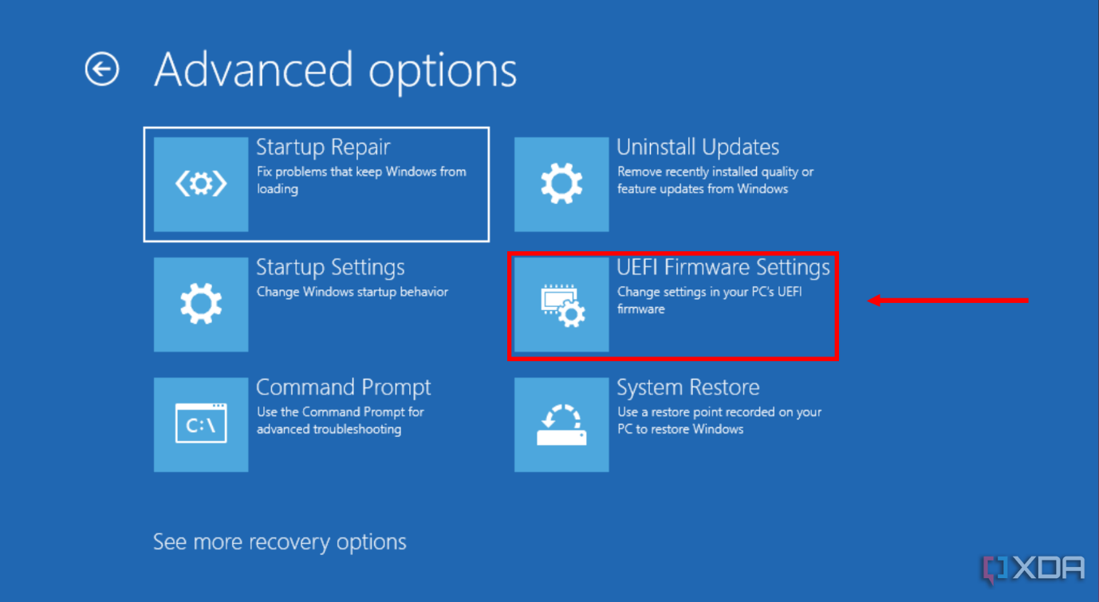

* This will take you to your PC's BIOS settings, where you can turn off Secure Boot. Turn off Secure Boot and Select Audit Mode.

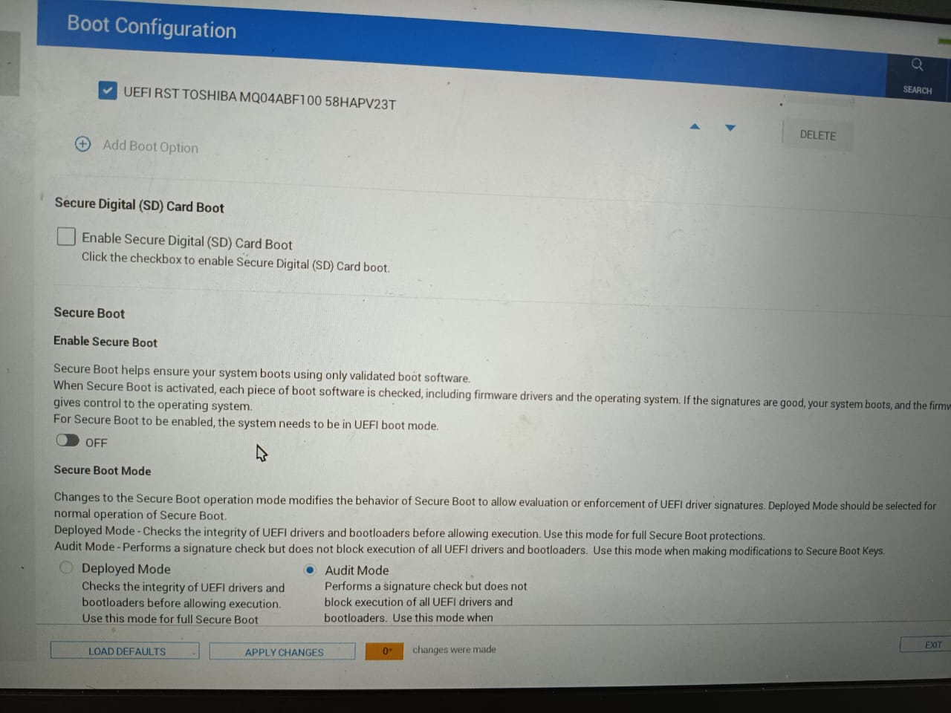

* Once it is disabled, restart the PC. It will ask for the BitLocker key.
* Enter the bitlocker key that you got from IT team.
* Restart the PC and get into windows

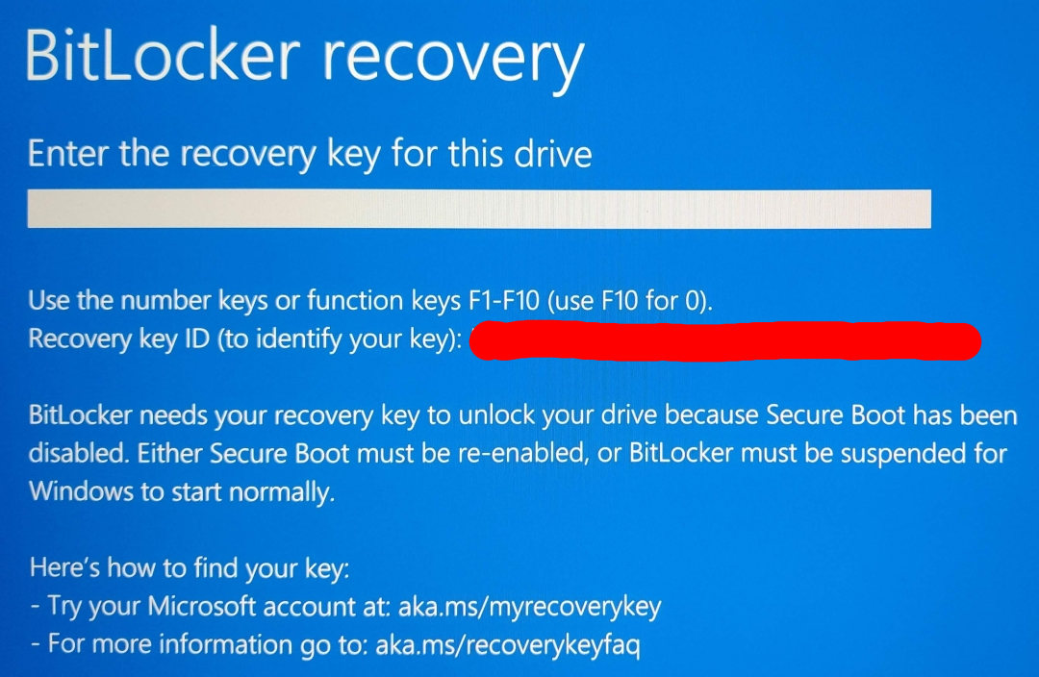

# Disable Bitlocker Encryption

* Press Win + S → search **“BitLocker”**
* Open **BitLocker Drive Encryption**
* Click **“Turn off BitLocker”** on your Windows drives
* Wait while it **decrypts the drive** — this can take some time depending on your SSD/HDD size

# Creating a partition to dual-boot Linux

* Next, you'll need to create a second partition on your drive for Linux. Here's how to create one.
* Right-click your Start menu icon (or press **Windows key + X** on your keyboard) and choose **Disk Management**. You'll see a list of your drives and partitions that should look something like this.

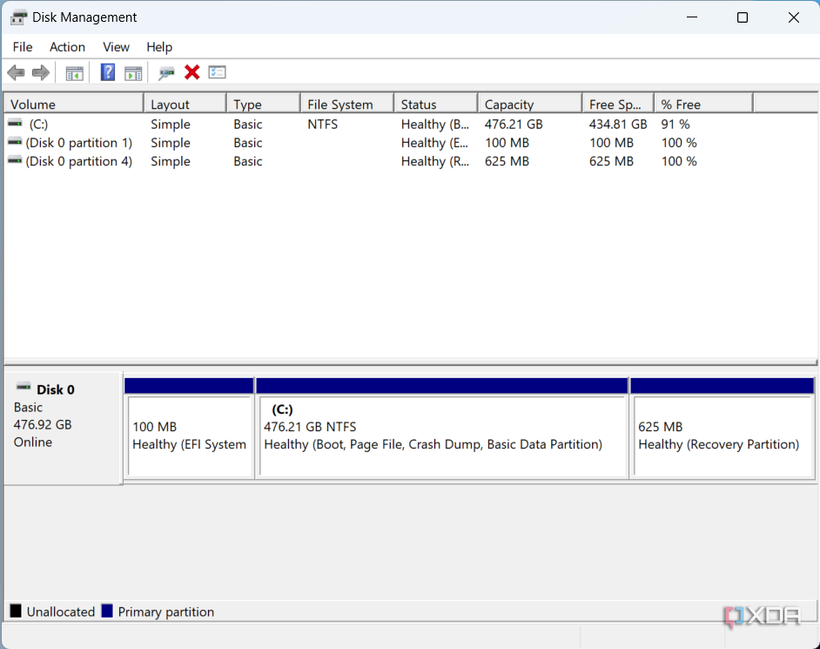

* Right-click your primary partition (it should be the one labeled as C:) and choose Shrink Volume...
* Specify the amount of space you want to remove from the partition. This will be limited by the files you already have stored on it, and the amount you enter will be the space you have for your Linux installation.
* The space you chose will be deducted from your partition, and it will be listed as unallocated space in the Disk Management window. You can leave it as is and close the window.

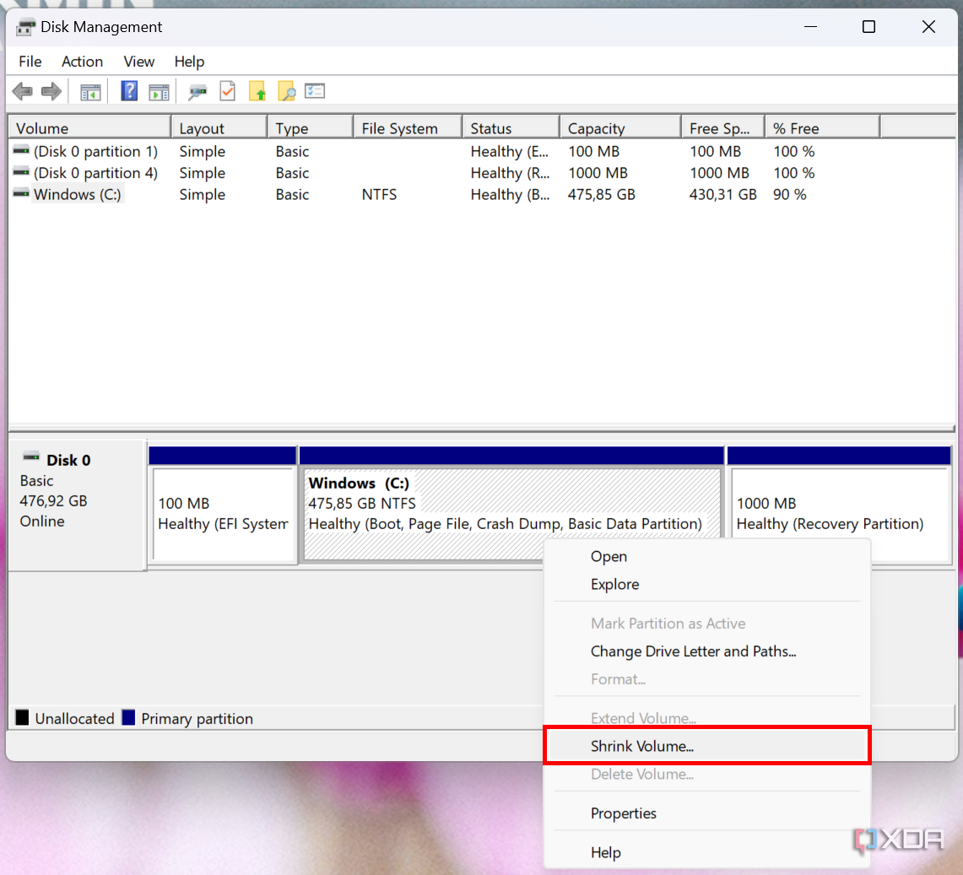

# Prepare the Ubuntu Bootable USB

* Insert the USB drive.
* Open Rufus (Rufus is used to create Bootable USB Drives)
* Run Rufus and insert the flash drive you want to use as installation media. Then, click **Select** and choose the ISO file you downloaded. All the options will be filled in automatically.
* Click on start to write the image to USB

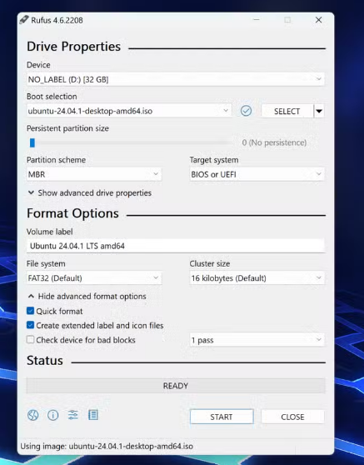

# Installing Linux to dual-boot with Windows 11

* Now you have the two main pieces of the puzzle, you're ready to install Linux on your empty partition. If you removed the USB installation media from your PC, insert it again (remove other flash drives), then follow these steps:
* Open the Start menu and then click the power button and — while holding **Shift** on your keyboard — click **Restart**.

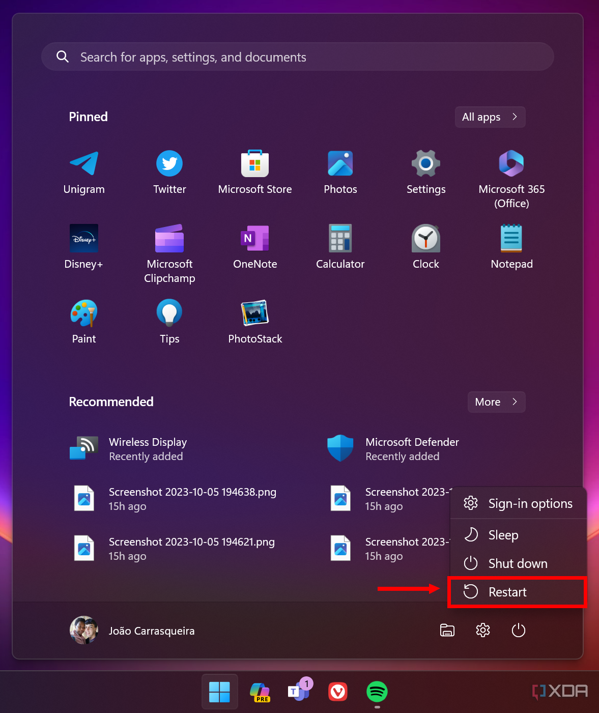

* You'll be given a series of boot options. Click Use a device, then choose the USB flash drive you have inserted and your PC will boot from it.

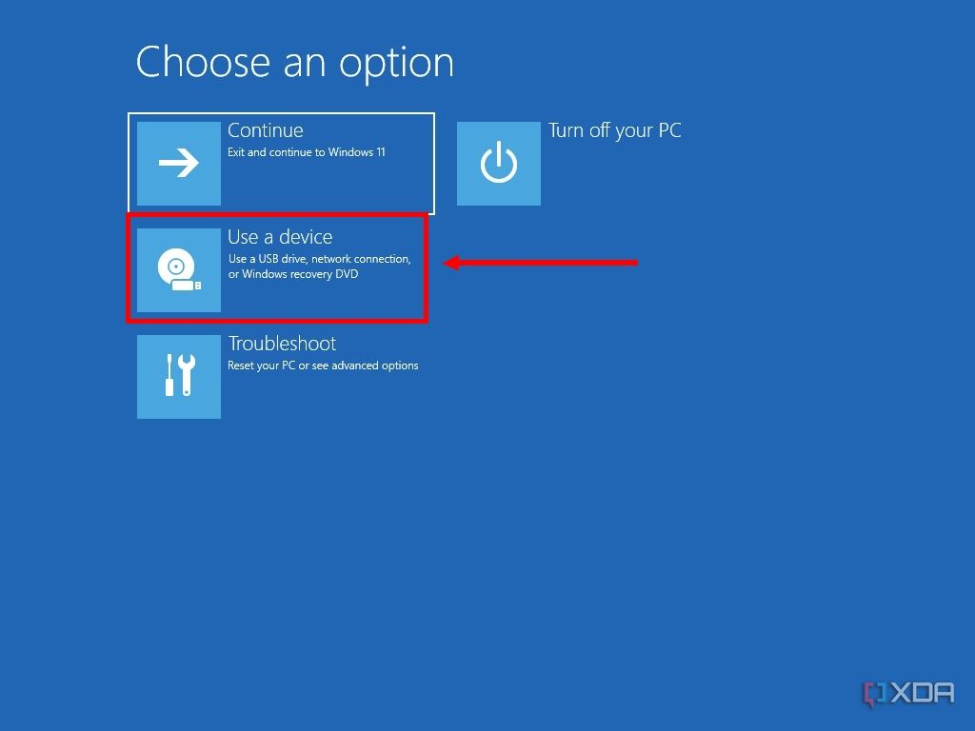

* You'll now be in the Ubuntu boot menu. Press Enter to boot into Ubuntu.
* Ubuntu and other Linux operating systems let you try it out by booting from the USB drive without installing it. To install Linux on your empty partition, click **Install Ubuntu**.

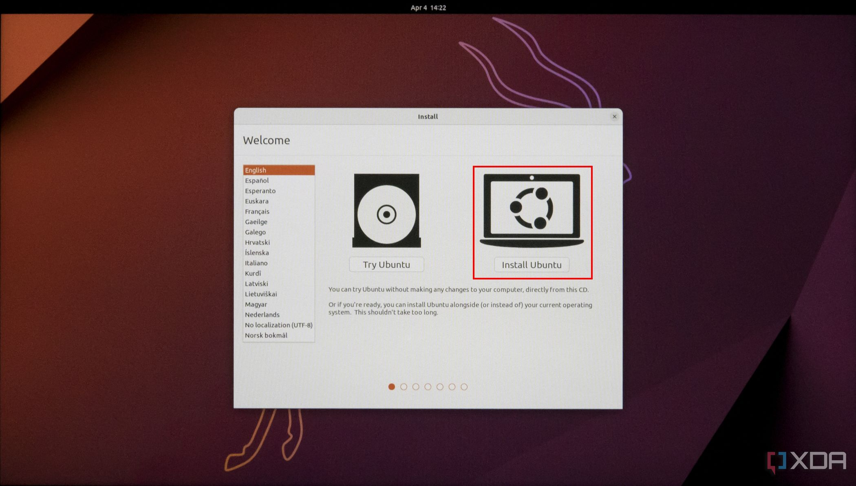

* Follow the setup experience by choosing your keyboard layout and connecting to Wi-Fi (optional). Choose your preferred options until you get to this page.

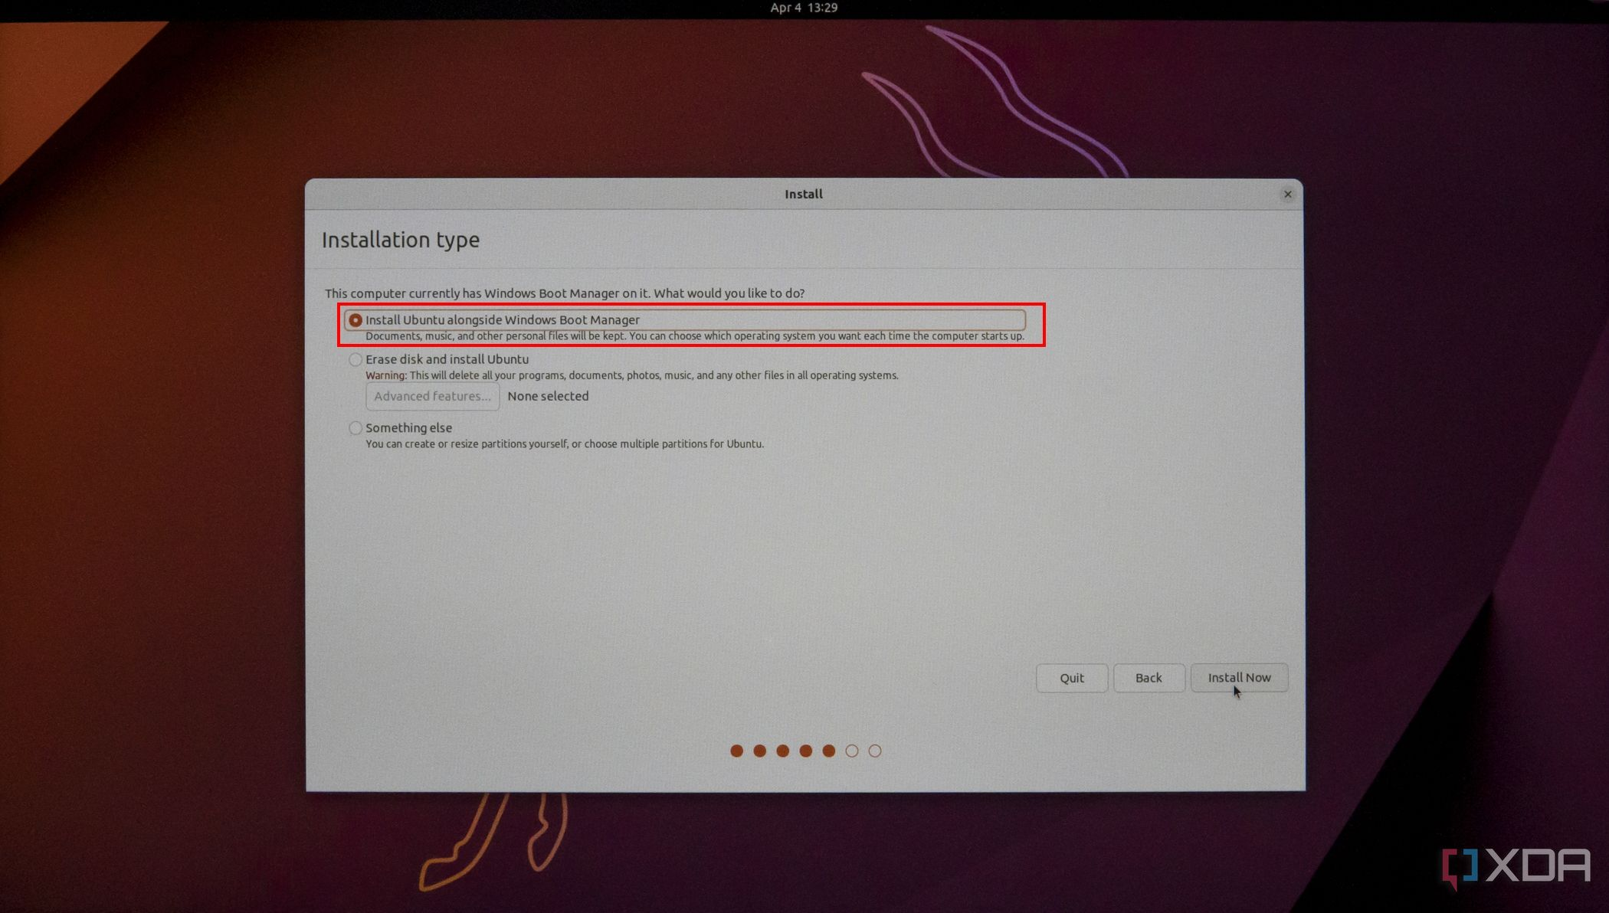

* Here, you'll want to choose the first option that's chosen by default, at least if you want the easiest way to do things. This will install Ubuntu on the unallocated space you created before, leaving your Windows installation intact.
* From here, it's mostly trivial stuff. Choose your region and set up your Ubuntu profile and the installation will begin. Once it's done, you'll be able to boot into Ubuntu without your USB flash drive.